Little's PDF Merge .How to use
Little's PDF Merge 2.2.2 beta running on Windows 10
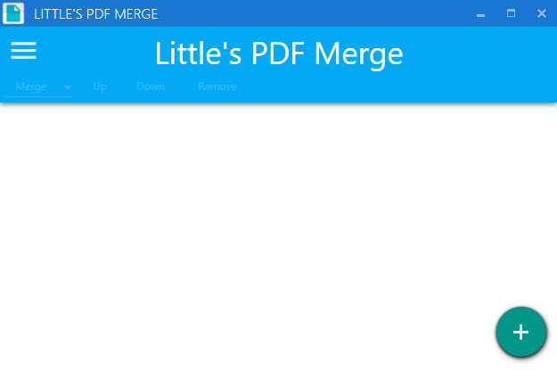Screenshot: Little's PDF Merge (WPF) Running on Windows 10

